2024 Fall Guidelines for
Yonsei-Keio Double Degree Program

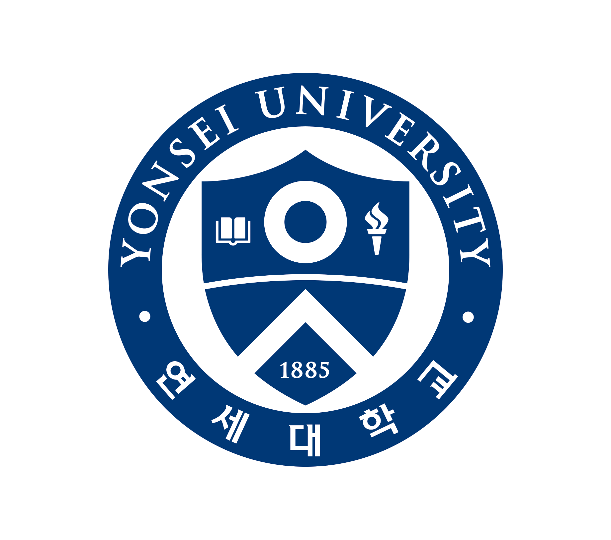

Yonsei University Graduate School

* This Guideline is designed for Keio University students who wish to enroll in the Double Degree Program of the master’s program at Yonsei University Graduate School in Fall 2024. Please read this guideline carefully before making the application.
Yonsei University Graduate School

I. General Information on the Yonsei – Keio Double Degree Program

1. Definition of a Double Degree Program
Participants concurrently enroll in Yonsei and Keio University while acquiring a Master’s degree from both graduate schools, given a minimum of two years study.

2. Participating Departments of the Double Degree Program at Yonsei University Graduate School and lists of Awarded Degrees
▪ Sociology → M.A in Sociology
▪ Political Science → M.A in Political Science
▪ Area Studies → M.A in Area Studies

3. Number of Student Intake
Yonsei University Graduate School (including Yonsei Graduate School of International Studies) accepts up to five students per one academic year under the Double Degree program. The number of students who will receive tuition waiver and financial support from Yonsei is three.

4. Academic Calendar (tentative)
* Spring Semester : From March 1 to Around June 20th
* Summer Break : From the end of Spring semester to the End of August
* Fall Semester : From September 1 to Around December 20th
* Winter Break : From the end of Fall semester to the End of February next year

5. Tuition Fee
Students who receive tuition waiver will pay tuition only to Keio University. This tuition waiver from Yonsei is available up to three students. However, if one decides to remain at Yonsei University after fourth semesters, he/she will be obliged to pay course fees to Yonsei University. The tuition will be calculated according to the unit(s) of enrolled credit. Tuition is adjusted on a semester-basis.

6. Financial Support
Financial support package of approximately KRW 4,000,000 will be provided to the student in installments for the first semester. These supports are available for three Keio students who receive the tuition waiver from Yonsei.

7. Period of Enrollment and Stay at Yonsei University
Keio Students participating in the Double Degree Program are required to enroll at least three semesters and required to stay at least one semester at Yonsei University. Depending on the student’s study plan and the area of specialization, students are allowed to stay up to two semesters if consent is received by Keio University and Yonsei University in advance.

8. Grade Point Scale
GRADE | POINT | EXPLANATION
A+ | 4.3 | Excellent
A0 | 4.0 | Excellent
A- | 3.7 | Excellent
B+ | 3.3 | Good
B0 | 3.0 | Good
B- | 2.7 | Good
C+ | 2.3 | Fair
C0 | 2.0 | Fair
C- | 1.7 | Fair
F | 0 | Fail
P,NP | 0 | Audit, Research

9. Requirements for Dual M.A Degree for students from Keio to Yonsei
1) Students must enroll in at least 3 semesters in the Yonsei Graduate School.
(Semesters previously enrolled at Keio can be counted.)
2) Students must complete a minimum of 30 academic credits including
Master’s thesis course. (0 credit)
* A maximum of 15 credits obtained at Keio may be transferred to fulfill the course credit requirements at Yonsei.
* Students may register up to 12 credits per semester.
3) Students must maintain a minimum cumulative GPA of 3.0 out of 4.3
4) Students must pass the qualification exam.
5) Students must pass the Master’s thesis.

10. The Master’s Thesis
Students must submit their Master’s thesis to Yonsei University, of which contents must not be the same from the ones submitted to Keio University (applicable only when students take thesis track in Keio). They should be written in Korean or English.
* The academic advisor and main referee evaluating the Master’s thesis must be a professor from Yonsei University. It is possible to include a professor from Keio University among the sub-referees.
* The preliminary presentation of the thesis can be made from Japan through Distance Learning System.
* The final thesis examination must be held at Yonsei University.
11. Module of the Double Degree Program
＊THE FOLLOWING CHART IS AN EXAMPLE. Students can start the Double Degree program at Yonsei after finishing one or two semesters at Keio. A student’s study plan can be flexibly arranged by personal choice, and the date of graduation from Yonsei and Keio may differ according to the student’s coordination. (It is possible to simultaneously obtain the degrees from Yonsei and Keio. It is also possible to obtain one degree first and obtain the other one later.)
Division |  | Keio → Yonsei |  | Remarks
Required Credits for Graduation |  | 30 Credits
Enrollment Options | 1st semester | ＊Take courses at Keio（no limit in the number of credits enrolled） | ＊Semester in Japan
Enrollment Options | 2nd semester | ＊Take courses at Keio（no limit in the number of credits enrolled） | ＊Semester in Japan
Enrollment Options | 3rd  semester | ＊Enroll in Yonsei. Possible to take a maximum of 12 credits. | ＊Semester in Korea  ＊Register at both Yonsei and Keio
Enrollment Options | 4th semester | * Yonsei – Take a 3-credit course and “Directed Research 1” (O credits)＋thesis  ＊Keio－Enroll in “Master’s Thesis Course” (2 credits)＋thesis | ＊Semester in Korea/Japan  ＊Register at both Yonsei and Keio
Enrollment Options | Total Number of Credits | 30 credits：  Yonsei will accept a maximum of 15 credits acquired from Keio University.  * A total of 15 credits must be acquired from Yonsei; this includes “Directed Research 1.”  * 2 courses (4 credits in total) at Keio equal 1 course (3 credits) at Yonsei.
Lecture Structure |  | One credit is equivalent to 15 weeks of 50 minute class in Yonsei University
II. Application Procedure for the Yonsei – Keio Double Degree Program

- Application Procedures
1) Please submit your application to the Administration Office of Keio University.
All documents must arrive at Yonsei through the Administration Office of Keio University by April 26(Fri), 2024.
2) Candidacy results will be notified to the Administration Office of Keio University in mid June, 2024.

- Application Eligibility
A student must meet all the following requirements:
1) Must be enrolled at Keio University Graduate School.
2) Must be capable of learning and communicating in Korean or English without difficulties.
3) Must hold excellent academic records.
4) Must be judged of having sufficient academic abilities to graduate from
Yonsei University Graduate School.

- Entrance Assessment
Assessment of applicants will be based on submitted documents. Assessment criteria for applicant consist of academic ability, academic enthusiasm demonstrated in the Statement of Purpose, research capabilities, etc.

- Required Documents
1) A complete application form(designated form) with a 3x4cm photo attached
(photo taken within 3 months)
2) Two letters of recommendation written in English by two professors from a previous university or graduate school (no designated form) (not mandatory but recommended)
3) Official undergraduate transcript and the Certificate of Graduation
(Submission of Apostille for the certificate of graduation is also necessary)
4) Official certificate of Enrollment and the Transcript at Keio University Graduate School
of Media and Governance
(Submission of Apostille for the certificate of Enrollment is also necessary)
5) Study plan written in Korean or English (no designated form)
6) A copy of passport
7) One original copy of language proficiency test results * (Test scores are not valid after 2 years from the test date.)
8) Korean Language Proficiency Evaluation Sheet (designated form)
9) Proof of Funds(Must be original copies)**

* Submit at least one document among TOPIK, TOEFL, TOEIC, TEPS, IELTS or any other document proving Korean or English proficiency (ex. Official degree certificate of university language schools, documents describing former high school or undergraduate confirming the usage of Korean or English during the course of study)
** Submit at least one of the documents listed below to prove your sponsorship described on the application form (Minimum amount of $20,000)
- Bank statements in your name showing the balance of the account (dated within 30 days from the application date)
- Your sponsor(your parents)’s bank statements and a document indicating the relationship between you and your parents (dated within 30 days from the application date)
- Proof of external scholarship covering your tuition and living expenses

- Notes
1) The candidacy results cannot be individually explained.
2) All documents must arrive by the deadline; incomplete applications will not be accepted.
3) Applicants will be disqualified if any application item is found to be untrue or dishonest.
4) Submitted documents and essays will not be returned.
5) Change of address or contact information must be immediately notified.

- Announcement of Results
The candidacy results of the Double Degree Program will be informed to Keio University’s Administration in mid June, 2024. Please contact the Academic Affairs Office for candidacy results.

